**“PL-SQL -- Exercise 1: Control Structures”**

**Scenario 1: The bank wants to apply a discount to loan interest rates for customers above 60 years old.**

* + **Question: Write a PL/SQL block that loops through all customers, checks their age, and if they are above 60, apply a 1% discount to their current loan interest rates.**

***SOLUTION:***

BEGIN

FOR cust_rec IN (

SELECT l.LoanID, l.InterestRate, c.DOB

FROM Loans l

JOIN Customers c ON l.CustomerID = c.CustomerID

) LOOP

-- Print initial status

DBMS_OUTPUT.PUT_LINE('Loan ID: ' || cust_rec.LoanID ||

' | Original Interest Rate: ' || cust_rec.InterestRate);

-- Check age

IF TRUNC(MONTHS_BETWEEN(SYSDATE, cust_rec.DOB) / 12) > 60 THEN

-- Apply 1% discount

UPDATE Loans

SET InterestRate = cust_rec.InterestRate - (cust_rec.InterestRate*0.01)

WHERE LoanID = cust_rec.LoanID;

-- Print updated status

DBMS_OUTPUT.PUT_LINE('→ Updated Interest Rate for Loan ID ' || cust_rec.LoanID ||

' to ' || TO_CHAR(cust_rec.InterestRate - 1));

DBMS_OUTPUT.PUT_LINE('----------------------------------------------------');

ELSE

DBMS_OUTPUT.PUT_LINE('→ No change (Customer under 60)');

DBMS_OUTPUT.PUT_LINE('----------------------------------------------------');

END IF;

END LOOP;

COMMIT;

END;

/

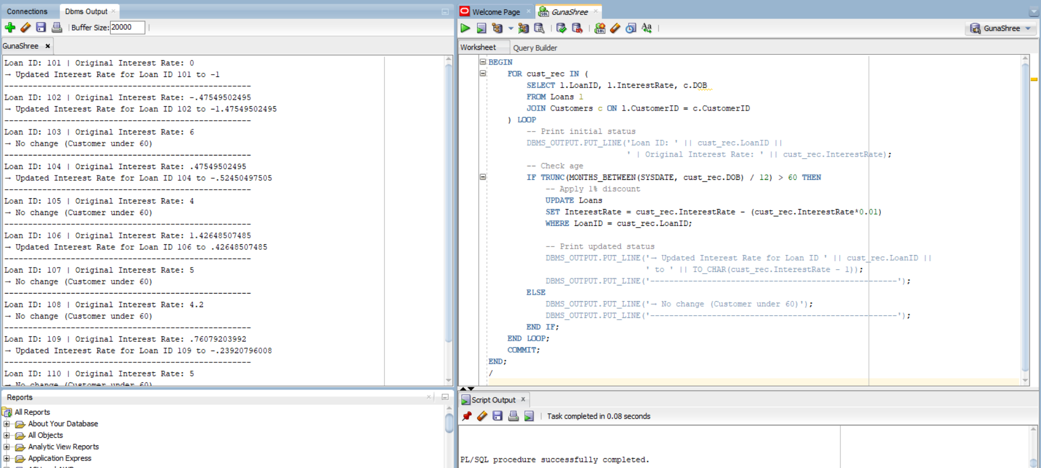



**--------------------------------------------------------------------------------------------------------------------------------------**

**Scenario 2: A customer can be promoted to VIP status based on their balance.**

* + **Question: Write a PL/SQL block that iterates through all customers and sets a flag IsVIP to TRUE for those with a balance over $10,000.**

***SOLUTION:***

SET SERVEROUTPUT ON;

ALTER TABLE Customers ADD IsVIP VARCHAR2(5);

BEGIN

FOR cust_rec IN (

SELECT CUSTOMERID, BALANCE

FROM CUSTOMERS

) LOOP

-- Print balance and VIP status before update

DBMS_OUTPUT.PUT_LINE('Customer ID: ' || cust_rec.CustomerID ||

' | Balance: ' || cust_rec.Balance);

IF cust_rec.BALANCE > 10000 THEN

UPDATE CUSTOMERS

SET IsVIP = 'TRUE'

WHERE CUSTOMERID = cust_rec.CUSTOMERID;

DBMS_OUTPUT.PUT_LINE('→ IsVIP status set to TRUE');

DBMS_OUTPUT.PUT_LINE('----------------------------------------------------------');

ELSE

UPDATE CUSTOMERS

SET IsVIP = 'FALSE'

WHERE CustomerID = cust_rec.CUSTOMERID;

DBMS_OUTPUT.PUT_LINE('→ IsVIP status set to FALSE');

DBMS_OUTPUT.PUT_LINE('----------------------------------------------------------');

END IF;

END LOOP;

COMMIT;

END;

/

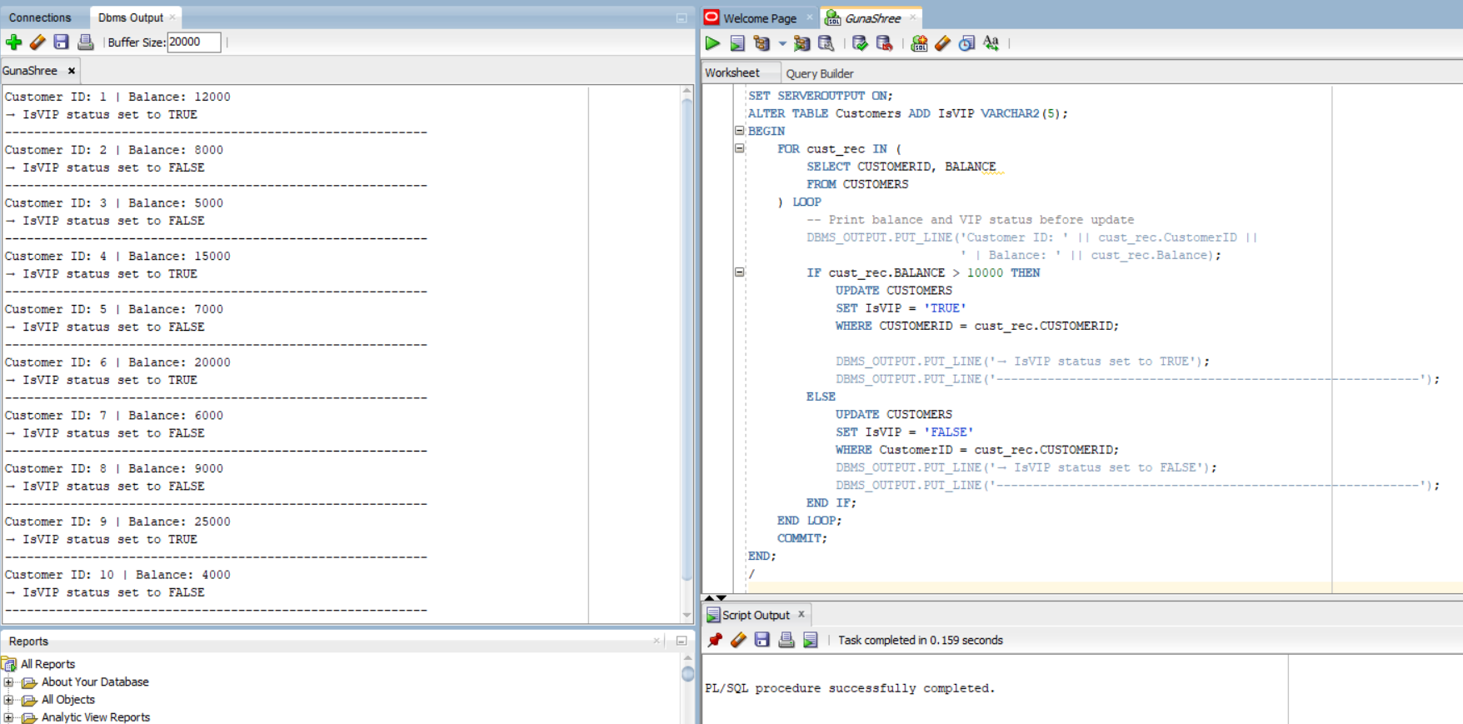



**Scenario 3: The bank wants to send reminders to customers whose loans are due within the next 30 days.**

**Question: Write a PL/SQL block that fetches all loans due in the next 30 days and prints a reminder message for each customer.**

***SOLUTION:***

BEGIN

FOR rec IN (

SELECT l.LoanID, l.EndDate, c.Name FROM Loans l

JOIN Customers c ON l.CustomerID = c.CustomerID

WHERE l.EndDate BETWEEN SYSDATE AND SYSDATE + 30

) LOOP

DBMS_OUTPUT.PUT_LINE(

'Reminder: Dear ' || rec.Name || ', your loan (Loan ID: ' || rec.LoanID ||

') is due on ' || TO_CHAR(rec.EndDate, 'DD-MON-YYYY') ||

'. Please ensure timely repayment.' );

END LOOP;

END;

/

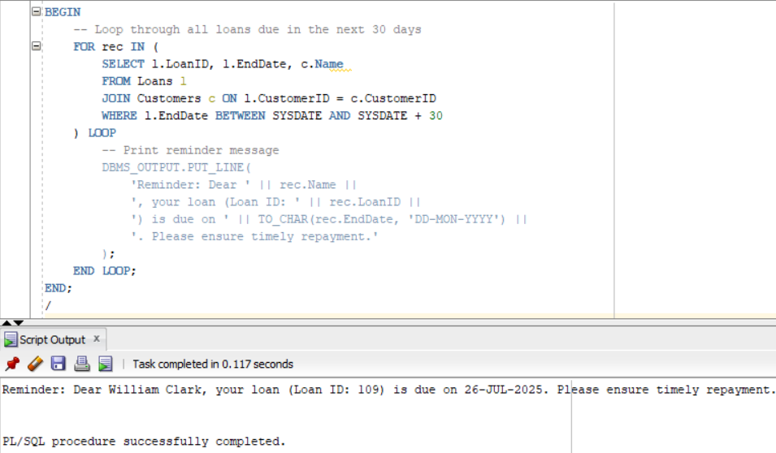

---------------------------------------------------------------------------------------------------------------------------

**“PL-SQL -- Exercise 3: Stored Procedures”**

**Scenario 1: The bank needs to process monthly interest for all savings accounts.**

* + **Question: Write a stored procedure ProcessMonthlyInterest that calculates and updates the balance of all savings accounts by applying an interest rate of 1% to the current balance.**

***SOLUTION:***

SET SERVEROUTPUT ON;

CREATE OR REPLACE PROCEDURE ProcessMonthlyInterest AS

v_new_balance NUMBER;

BEGIN

DBMS_OUTPUT.PUT_LINE('--- Monthly Interest Processing Started ---');

-- Loop through all savings accounts

FOR acc_rec IN (

SELECT AccountID, Balance

FROM ACCOUNTS

WHERE AccountType = 'Savings'

) LOOP

-- Calculate new balance

v_new_balance := acc_rec.Balance + (acc_rec.Balance * 0.01);

-- Show before and after in output

DBMS_OUTPUT.PUT_LINE('Account ID: ' || acc_rec.AccountID);

DBMS_OUTPUT.PUT_LINE(' Before: Rs. ' || acc_rec.Balance);

DBMS_OUTPUT.PUT_LINE(' After: Rs. ' || TO_CHAR(v_new_balance, '9999990.00'));

DBMS_OUTPUT.PUT_LINE('--------------------------------------------------------------------');

-- Update the balance

UPDATE Accounts

SET Balance = v_new_balance,

LastModified = SYSDATE

WHERE AccountID = acc_rec.AccountID;

END LOOP;

COMMIT;

DBMS_OUTPUT.PUT_LINE('--- Monthly Interest Processing Completed ---');

END;

/

EXEC ProcessMonthlyInterest;

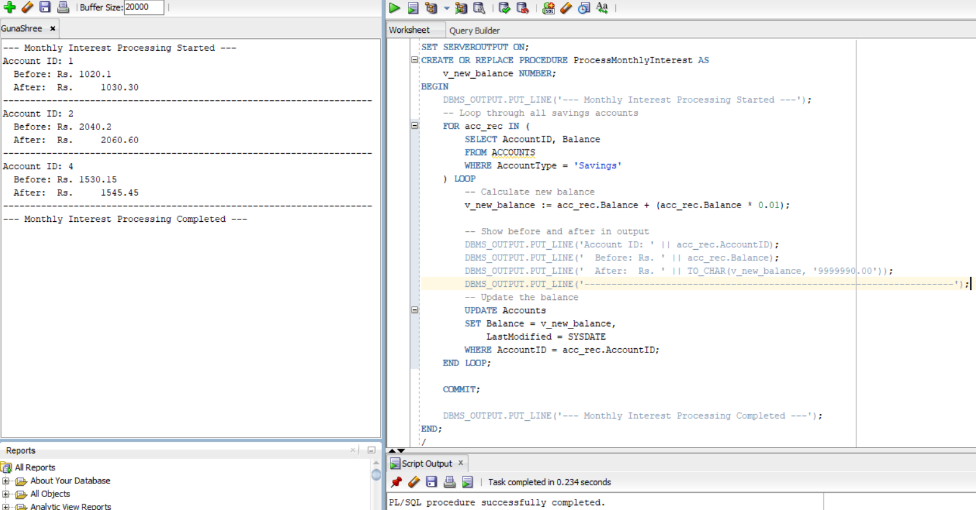



---------------------------------------------------------------------------------------------------------------------------

**Scenario 2: The bank wants to implement a bonus scheme for employees based on their performance.**

* **Question: Write a stored procedure UpdateEmployeeBonus that updates the salary of employees in a given department by adding a bonus percentage passed as a parameter.**

***SOLUTION:***

SET SERVEROUTPUT ON;

CREATE OR REPLACE PROCEDURE UpdateEmployeeBonus (

p_department IN VARCHAR2,

p_bonus_pct IN NUMBER -- e.g., pass 10 for 10%

) AS

v_bonus_amt NUMBER;

BEGIN

DBMS_OUTPUT.PUT_LINE('--- Bonus Update for Department: ' || p_department || ' ---');

FOR emp_rec IN (

SELECT EmployeeID, Department, Salary

FROM Employees

WHERE Department = p_department

) LOOP

-- Calculate bonus

v_bonus_amt := emp_rec.Salary * (p_bonus_pct / 100);

-- Display ID, Dept, and Bonus

DBMS_OUTPUT.PUT_LINE('ID: ' || emp_rec.EmployeeID ||

' | Dept: ' || emp_rec.Department ||

' | Bonus: ' || TO_CHAR(v_bonus_amt, '999999.00'));

-- Update salary

UPDATE Employees

SET Salary = Salary + v_bonus_amt

WHERE EmployeeID = emp_rec.EmployeeID;

END LOOP;

COMMIT;

DBMS_OUTPUT.PUT_LINE('--- Bonus Applied Successfully ---');

END;

/

EXEC UpdateEmployeeBonus('IT',10);

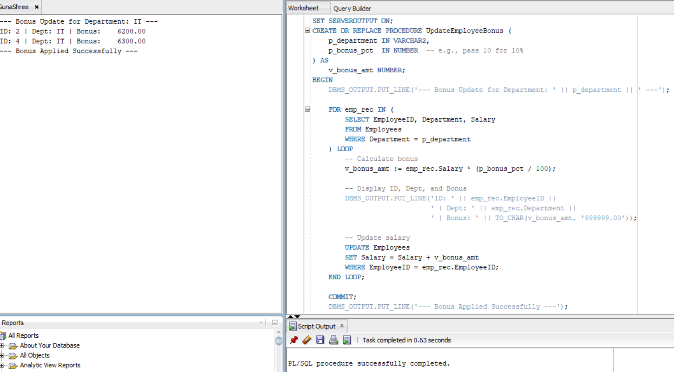



---------------------------------------------------------------------------------------------------------------------------

**Scenario 3: Customers should be able to transfer funds between their accounts.**

* + **Question: Write a stored procedure TransferFunds that transfers a specified amount from one account to another, checking that the source account has sufficient balance before making the transfer.**

***SOLUTION:***

SET SERVEROUTPUT ON;

CREATE OR REPLACE PROCEDURE TransferFunds (

p_source_account_id IN NUMBER,

p_destination_account_id IN NUMBER,

p_amount IN NUMBER

) AS

v_source_balance_before NUMBER;

v_destination_balance_before NUMBER;

v_source_balance_after NUMBER;

v_destination_balance_after NUMBER;

BEGIN

DBMS_OUTPUT.PUT_LINE('--- Transfer Initiated ---');

-- Step 1: Get balances before transfer

SELECT Balance INTO v_source_balance_before

FROM Accounts

WHERE AccountID = p_source_account_id;

SELECT Balance INTO v_destination_balance_before

FROM Accounts

WHERE AccountID = p_destination_account_id;

DBMS_OUTPUT.PUT_LINE('BEFORE TRANSFER:');

DBMS_OUTPUT.PUT_LINE('Source Account (ID ' || p_source_account_id || '): Rs. ' || v_source_balance_before);

DBMS_OUTPUT.PUT_LINE('Destination Account (ID ' || p_destination_account_id || '): Rs. ' || v_destination_balance_before);

-- Step 2: Check if source account has sufficient balance

IF v_source_balance_before < p_amount THEN

RAISE_APPLICATION_ERROR(-20001, 'Insufficient balance in source account.');

END IF;

-- Step 3: Perform the transfer

UPDATE Accounts

SET Balance = Balance - p_amount,

LastModified = SYSDATE

WHERE AccountID = p_source_account_id;

UPDATE Accounts

SET Balance = Balance + p_amount,

LastModified = SYSDATE

WHERE AccountID = p_destination_account_id;

-- Step 4: Get balances after transfer

SELECT Balance INTO v_source_balance_after

FROM Accounts

WHERE AccountID = p_source_account_id;

SELECT Balance INTO v_destination_balance_after

FROM Accounts

WHERE AccountID = p_destination_account_id;

DBMS_OUTPUT.PUT_LINE('AFTER TRANSFER:');

DBMS_OUTPUT.PUT_LINE('Source Account (ID ' || p_source_account_id || '): Rs. ' || v_source_balance_after);

DBMS_OUTPUT.PUT_LINE('Destination Account (ID ' || p_destination_account_id || '): Rs. ' || v_destination_balance_after);

COMMIT;

DBMS_OUTPUT.PUT_LINE('Transfer of Rs. ' || p_amount || ' completed successfully.');

DBMS_OUTPUT.PUT_LINE('-----------------------------');

EXCEPTION

WHEN NO_DATA_FOUND THEN

RAISE_APPLICATION_ERROR(-20002, 'One of the accounts does not exist.');

WHEN OTHERS THEN

ROLLBACK;

RAISE;

END;

/

BEGIN

TransferFunds(1, 2, 500); -- Transfer ₹500 from AccountID 1 to 2

END;

/





